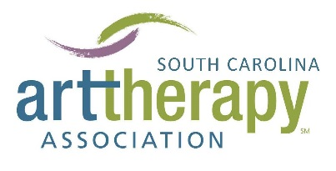

South Carolina art therapists need your help!

We are collecting testimonials and/or advocacy letters to support efforts in achieving needed licensure in the state. Your support and attention to a state art therapy license is greatly appreciated and vital for the health, safety, and well-being of residents across South Carolina. Feel free to pass along this information to colleagues, directors, supervisors, agencies, organizations, licensed clinicians, individuals involved with governmental affairs, or patients or clients that have been impacted by art therapy.
Please find the following template and sample endorsement letters from various organizations or individuals as reference (including one from Mayor Tecklenburg!).

If you have questions or comments please contact the South Carolina Association of Art Therapists (SCAAT) at govaffairs@scarttherapy.com.
Thank you!

Why do we need licensure?

Credentialed art therapists, art therapy clients, and mental health colleagues in South Carolina believe a state art therapy license through the SC Labor, Licensing and Regulation Department is urgently needed to:
- Protect the public by ensuring that those in need of art therapy services receive them from qualified, trained professionals who meet the approved training, educational, and credentialing requirements.
- Increase affordable access to mental health services by providing a distinct service and reimbursement code under public and private insurance for licensed art therapists.
- Attract and retain qualified art therapy professionals and art therapy students in South Carolina.
- Contribute to the economy of the state through expansion of art therapists’ businesses and practices, increased employment, payment of taxes, and state licensure and renewal fees.

State licensure of professional art therapists will also support assessment and treatment for (but not limited to):
- Veterans, active duty military, and their families who are experiencing mental health problems, including PTSD, traumatic brain injury, depression, and increasing rates of suicide.
- The growing numbers of older adults with dementia and depression.
- People of all ages in the healthcare setting who need complimentary therapies to increase quality of life and cope with the physical and emotional symptoms of diagnosis and treatment.
- Individuals diagnosed with developmental disabilities (i.e., autism) who need specially trained and qualified therapists.
- Those experiencing trauma from natural disasters, abuse, drug dependency, or other mental health problems in the general population.

TEMPLATE

PERSONAL/ORGANIZATION/AGENCY NAME

To Whom It May Concern,
My name is YOUR NAME and I am JOB TITLE AND ORGANIZATION in YOUR CITY, STATE. I KNOW/WORK WITH/ HAVE WORKED WITH an art therapist at NAME OF AGENCY(IES). I fully support the licensure efforts of art therapists in South Carolina and advocate for the safety of South Carolina residents by establishing a state art therapy license. I am dedicated to closing the current gap between mental health diagnoses and affordable, quality treatment in South Carolina – and believe a state art therapy license will help achieve this goal.
Art therapy is a distinct mental health profession in which clients, facilitated by a masters-level art therapist, use art media, the creative process, and the resulting artwork to achieve mental, emotional, physical, and spiritual goals. Art therapists are clinically trained to work with clients of all ages and are working in community, medical, and private settings throughout the country. Art therapy goals can range from coping with trauma and safe self-expression to enhancing cognitive and motor abilities and relieving stress and anxiety.
PLEASE PERSONALIZE BY SHARING YOUR EXPERIENCE WORKING WITH/SEEING THE IMPACT OF AN ART THERAPIST HERE
Your support and attention to a state art therapy license is greatly appreciated and vital for the health, safety, and well-being of residents across the state of South Carolina.
Thank you again for your time, energy, and service to the residents of South Carolina. I look forward to being in touch.
Sincerely,
YOUR NAME, POSITION OR TITLE (IF APPLICABLE)

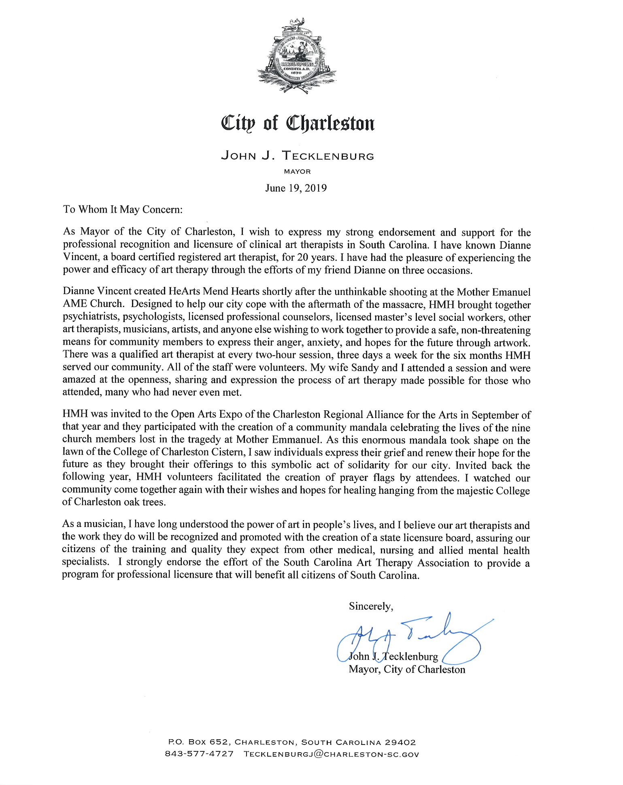
SAMPLE ENDORSEMENT LETTER – CHILDREN’S/UNIVERSITY HOSPITAL

To Whom It May Concern,

On behalf of the medical staff of Monroe Cabell Jr. Children’s Hospital at the University of Kentucky, I want to express our strong endorsement and support of efforts by the Kentucky Art Therapy Association to gain enactment of legislation for licensure of professional art therapists under the State Board of Professional Counseling and Marriage and Marriage and Family Therapy Examiners. Our clinical art therapy program has been an important component of the care provided to infants and children at Children’s Hospital since the program began in 2004. The program is directed by a Board Certified Art Therapist, Pamela Harris, and is supported by the Junior League of Louisville.

The role of the art therapist at Children’s Hospital is to address the physical and emotional needs of pediatric patients through a variety of educational and healing art experiences. These activities provide opportunities for children to explore problems and potentials, reaffirm their self-image and, in more basic terms, let them have fun. Our art therapists provides group sessions, individualized bedside sessions, and our Rainbow Channel TV programming that enables patients, family and staff alike to experience the expressive and therapeutic qualities of art creation and the visual arts.

The unique role of art therapy in a medical setting is providing children with an opportunity to see themselves not as passive patients, but active partners in the work of getting well. Our art therapists provide tools that allow children to cope with the pain and isolation children must endure, process scary and potentially traumatizing medical experiences, and safely express a range of feelings they may have about their treatment in an often bewildering medical environment. The art therapist is able to recognize themes, concerns, and needs because they are both actively listening to the patient and their partners in the treatment team. One of the unique aspects of art therapy in the hospital setting is its ability to facilitate communication and help build trust and community.

The philosophy of care at Children’s Hospital is to do everything possible to ensure a positive experience for each patient. Art therapy is an important component of that commitment. Highly trained and qualified art therapists, like those involved in the clinical art therapy program at Children’s Hospital, deserve the same professional recognition that state licensure provides to all their colleagues in other medical, nursing and allied health specialties. We urge support for legislation to provide a program of professional licensure that will benefit both art therapists and all citizens of Kentucky.

Sincerely,

Director of Medical Services

SAMPLE ENDORSEMENT LETTER – VETERANS’ CENTER

To Whom It May Concern,

I am writing to express my strong support for licensure of professional art therapists by the Division of Health Professions Licensure of the Missouri Department of Public Health. As Director of Wellness and Supportive Services for the Veterans Outreach Center (VOC) in Saint Louis, I experience daily the many benefits that art therapy provides our service men and women who suffer traumatic brain injuries and psychological health conditions by helping to mitigate anxiety and depression and providing a nonverbal outlet to express emotions and process traumatic experiences.

The Center offers a program of clinical art therapy, an established mental health profession that combines traditional psychotherapeutic theories and techniques with an understanding of the creative process. Art therapy is provided by therapists who are nationally registered (ATR) and board certified (BC) to practice art therapy and psychotherapy. Every client works with a dedicated case manager who ensures individual attention to tailor access to services that meet their needs. By the very nature of the work, art therapists empower veterans to express their experiences by offering choice to a wide variety of materials, giving control over the therapy process and pace and creating opportunities to mold, shape, paint, cut, sew, glue, draw, and in the process transform congnitions, emotions, and recollections of combat experiences. Self esteem increases as veterans are supportive witnesses to each other’s struggles and growth.

The mission of our Wellness and Supportive Services program at the Veterans Outreach Center is to ensure veterans’ success by overcoming barriers to economic well-being, employment, physical and mental health. The clinical art therapy program is one of our core supportive services in meeting this mission and facilitating referrals for other needed services available at the Center and other VA facilities.

I urge the Department of Public Health and the Missouri legislature to help address the growing need for mental health services among veterans and other groups in our state by providing professional recognition and licensure of clinical art therapists.

Sincerely,

Director of Wellness and Support Services
SAMPLE ENDORSEMENT LETTER – SCHOOL DISTRICT

To Whom It May Concern,

I am writing on behalf of the administration of the Miami-Dade County Public Schools (M-DCPS) to endorse your association’s legislative effort to obtain professional licensure for art therapists by the Florida Department of Health Services.

The M-DCPS Clinical Art Therapy Program has been an integral part of our K-12 curriculum since it began as a pilot program in 1992. The program is dedicated to helping at-risk students reach their maximum cognitive and emotional potential through the vehicle of creative expression. The program has grown consistently over the years. Presently, we have twelve master’s trained art therapists and three supervised art therapy interns providing services to approximately 400 students countywide.

The art therapists employed by M-DCPS help students identified with E/BD to identify and reconcile emotional conflicts using art processes as the modality for personal expression, communication, evaluation, and treatment. Art therapy uses the creative process as a vehicle for communication to help students develop insights, resolve emotional conflicts, and make positive behavioral changes. Our trained art therapists observe and analyze a student’s behaviors and art products to design and implement appropriate therapeutic interventions. They are integral members of a team, working directly with teachers, administrators, mental health professionals, outside agencies and parents. Since school counseling relies heavily on verbal communication, the role of art therapy in eliciting both verbal and non-verbal expressions of feelings has been critical to our continued success in helping all our students understand their feelings and adopt socially acceptable behaviors.

The administration of the Miami-Dade County Public Schools strongly endorses the effort of the Florida Art Therapy Association to gain professional recognition and licensure of art therapists to assure that all our students will continue to have access art therapy services by highly trained and qualified art therapy professionals.

Sincerely,

Superintendent, M-DCPS

